

**KWANTLEN POLYTECHNIC UNIVERSITY**

**SCHOOL OF BUSINESS**

**INFO 2313 – System Development Project S10**

**Project:**

Project Suits

**Submitted To:**

Nukhet, Tuncbilek

**Prepared By:**

Danish Saini - 100429504

Sahiba - 100441016

Komalpreet Kaur - 100445690

Sophia Kaur -

Carl Nikoi – 100439006

**TABLE OF CONTENTS**

BASELINE PROJECT PLAN 1

PROJECT “SUITS” 1

Introduction 1

Scope 1

System Description 3

Feasibility Assessment 4

Management 5

Baseline Project Plan Review 7

Walkthrough Review Form 7

Walkthrough Action List 9

**LIST OF TABLES**

Table 1 Project Communication Plan 6

Table 2 Responsibility Matrix 12

Table 3 Project Charter 13

**LIST OF FIGURES**

Figure 1 Gannt Chart 10

# **BASELINE PROJECT PLAN**

## **PROJECT “SUITS”**

### Introduction

In today’s evolving digital era, Pearson Specter is embarking on the journey to a transition from paper-based documentation to an efficient electronic system. This proposal outlines the scopes, objectives, recommendations, and outcomes for the development of a web-based platform to meet the needs of the firm.

### Scope

#### **General Project Information**

Project “Suits” aims to create a centralized platform for all the employees of Pearson Specter where through Role-Based Access Control, they get streamlined access to essential documents.

#### **Problem/Opportunity Statement**

Employees have to call their assistants or run themselves to the copy room every time they forget a document, what if there was a system where they could just upload their document and access it whenever they want? This project targets this problem and is a robust solution for all the employees of Pearson Specter.

#### **Project Objectives**

* 1. Design and implement a user-friendly website interface for Pearson Specter employees.
  2. Integrate Role-Based Access Control functionality to ensure secure document access.
  3. Develop a robust backend system for document management and storage.
  4. Provide comprehensive training and support for employees to effectively utilize the platform.

#### **Project Description**

Development of this project will include creating a website for Pearson Specter, where all employees, using their unique employee ID can sign in, and based on their job roles and position, access the material required for any occasion. Using this cutting-edge Role-Based Access Control Technology, security and integrity will be assured.

#### **Business Benefits**

1. *Increased productivity:* Employees will spend less time searching for documents, leading to improved efficiency.
2. *Enhanced data security:* Role-Based Access Control will restrict document access to authorized personnel only, minimizing the risk of data breaches.
3. *Streamlined document management:* Centralized storage and organization of documents will simplify administrative tasks and reduce errors.
4. *Competitive advantage:* Demonstrating a commitment to technological innovation and employee welfare can enhance the company's reputation and attract top talent.

#### **Project Deliverables**

1. A fully functional website with an intuitive user interface.
2. Role-Based Access Control system integrated into the platform.
3. Backend infrastructure for document management and storage.
4. Comprehensive user documentation and training materials.
5. Ongoing support and maintenance plan for the website.

#### **Estimated Project Duration**

This project development team aims to complete this project within 4 months from May 2024, i.e., by 12 Aug 2024. This timeline will include every stage of development utilizing all phases of the Software Development Life Cycle (SDLC): Planning, Requirement Gathering and Analysis, Design, Implementation, Testing, Development, and Maintenance.

## **System Description**

#### **Alternatives**

For developing an electronic documentation system for the Pearson Specter, various alternative solutions like off-the-shelf software (pre-built software) and custom development were considered. After a careful evaluation, a web-based application was considered the best solution for meeting the requirements of the firm by ensuring seamless functionality, scalability, and reliability in the firm.   
 **Narrative of Input Information and Tasks Performed**

* The system will be a web-based application that can be accessed through web browsers across different devices.
* The system will include a login environment where the users can sign in according to their credentials.
* The system will consist of various legal documents such as agreements, case status, contracts, evidence, court filings, and client meetings which will be uploaded by users through the integration of external databases.
* Users will upload the documents using the relevant data such as document type, client number, and case number.
* Users will access the folders or documents in the system according to their access rights and can edit or delete as per the requirement.
* Users will easily locate and access the desired documents using the keywords, document type, or client name.

#### **Resultant**

* The new system will provide access to documents in an organized, searchable repository which will facilitate efficient document management and collaboration.
* The system will be user-friendly and easy to navigate.
* The system will protect the security of documents and personal information.

## **Feasibility Assessment**

#### **Economic Feasibility**

1. *Cost-benefit Analysis* – This will include development, maintenance, and overhead expenses while installing a new system.
2. The *return on investment* calculation will be done by taking into account tangible (cost savings, revenue generation) and intangible factors (user satisfaction, competitive advantage).

#### **Technical Feasibility**

1. A whole new IT infrastructure, hardware, and software will be installed to develop the electronic documentation system. There can be some disruptions at the first time but can be solved by ensuring the appropriate integration with the database and a proper assessment of the new technology.
2. The scalability and performance of the system will be assessed timely so that future growth with a lot of documents can be accommodated along with optimal performance

#### **Legal and contractual feasibility**

According to our plan, the new system will be developed by us so there will be no issues related to copyrights, ownership, or intellectual property rights.

#### **Political Analysis**

1. To create the electronic documentation system, the communication between the stakeholders will be done effectively so that the goals and expectations are aligned among the members.
2. In addition to this, training and support will be provided to the users, so the agenda of collaboration and innovation is maintained.

#### **Operational Analysis**

1. The focus of our plan is to make the documentation electronic, and for gathering the feedback or issues related to the new system, the conduction of user surveys will be done.
2. While implementing the system, different kinds of user errors or system failures can exist which will be resolved by making new risk mitigation strategies and plans to ensure streamlined operations within the law firm.

**Schedule Analysis**   
 Our main focus is to complete the project in 4 months (approx.). All adequate financial and human resources will be ensured so that the project deadlines and milestones can be achieved with minimal schedule disruptions. Every factor such as deployment, testing, training, and user adoption is considered to develop a realistic project timeline.

## **Management**

**Team Configuration and Management**  
To ensure team management and communication during the project lifecycle, the following task matrix and communication plan will be implemented:

|  |  |  |  |  |
| --- | --- | --- | --- | --- |
| **Member** | **Role** | **Document** | **Contact** | **Contact procedure** |
| Danish  Saini | Project  Manager and Developer | Project  Status  report | [danish.saini@student.kpu.ca](mailto:danish.saini@student.kpu.ca) +1 604-723-5160 | Weekly  email / weekly status meetings |
| Sahiba | Team lead and Standards  bearer | Project  Status  report | [sahiba.sahiba@student.kpu.ca](mailto:sahiba.sahiba@student.kpu.ca)  +1 672-377-3337 | Email/ weekly status meetings/ Messaging |
| Komalpreet Kaur | Team member | Project  Status  report | [komalpreet.kaur61@student.kpu.ca](mailto:komalpreet.kaur61@student.kpu.ca)  +1 778-889-1074 | Email/ weekly status meetings/ Messaging |
| Sophia  Kaur | Team member | Project  Status  report | [sophiakaur@student.kpu.ca](mailto:sophiakaur@student.kpu.ca)  +1778-688-0219 | Email/ weekly status meetings/ Messaging |
| Carl Nikoi | Team member | Project  Status  report | [carl.nikoi@student.kpu.ca](mailto:carl.nikoi@student.kpu.ca)  +236-514-2181 | Email/ weekly status meetings/ Messaging |
| User group | Customer | Project  Status  report | nukhet.tuncbilek@kpu.ca | Weekly Email |

Table 1 Project Communication Plan

## **Baseline Project Plan Review**

Periodic walkthroughs will be conducted to showcase the system functionalities, get feedback, and get validation from the client. Incorporating the client's involvement in the development will ensure that the final product meets the needs and preferences.

**Pearson Specter**

## **Walkthrough Review Form**

**Project Name**: Project Suits

**Session Coordinator**: Danish Kumar Saini

**Date**:

#### **Overview**

* Purpose of Walkthrough
* To review the product created during the system development cycle.
* To identify issues, errors, or need improvement.

**Responsibilities Participants** **Can Attend**

Coordinator [ ] Y [ ] N

Presenter [ ] Y [ ] N

User [ ] Y [ ] N

Maintenance [ ] Y [ ] N

Standards [ ] Y [ ] N

#### **Product Review and Process**

* Description of the product being reviewed.
* Criteria used to evaluate the product.
* Agenda items and topics covered during the meeting.
* Roles assigned to the participants.

#### **Feedback and Action Items**

* List of issues, errors or concerns raised during the walkthrough.
* Suggestions or recommendations identified for enhancing the system.
* Roles assigned to the specific members for the action items.

#### **Walkthrough Summary**

* Summary of key findings and observations from the walkthrough.
* Revise (no walkthrough).
* Review and schedule another Walkthrough.

Signature:

**Pearson Specter**

## **Walkthrough Action List**

**Project Name**: Project Suits

**Session Coordinator**: Danish Kumar Saini

**Date**:

|  |  |
| --- | --- |
| * Fixed | Issues Raised in Review: |
|  |  |
|  |  |
|  |  |
|  |  |
|  |  |
|  |  |
|  |  |
|  |  |
|  |  |
|  |  |

#### **Preliminary Schedule - Gantt Chart**

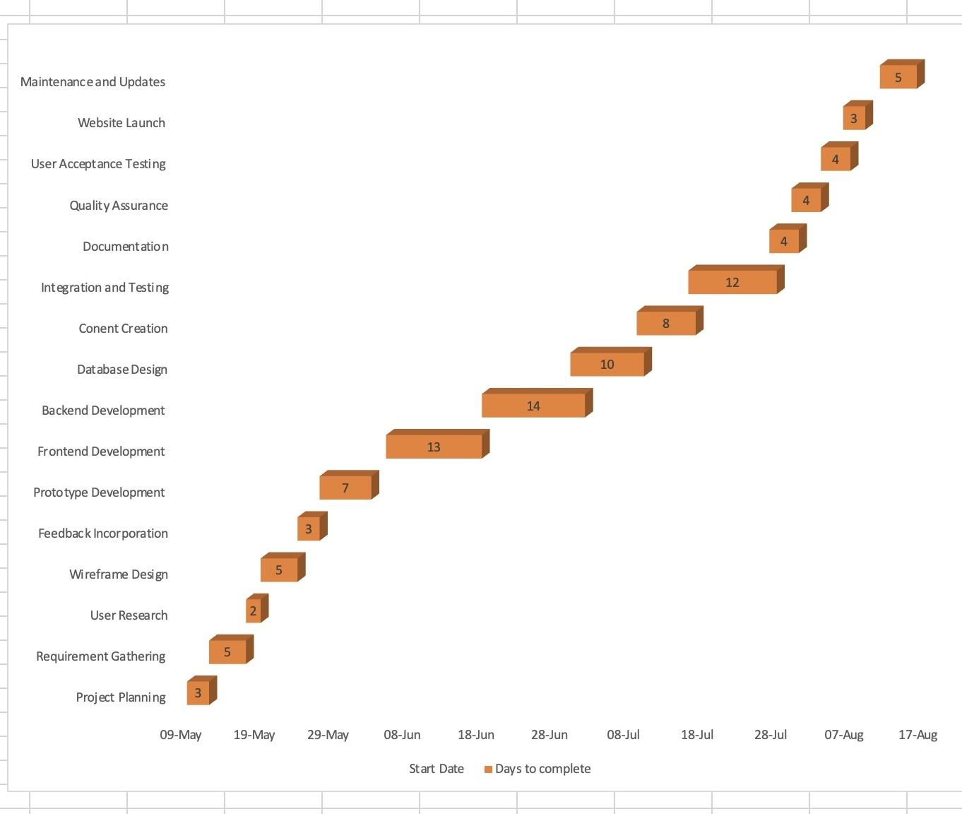

Figure 1 Gannt Chart

|  |  |  |
| --- | --- | --- |
| Project: Suits | Prepared by:  Sophia Kaur | Legend:  P = Primary  S= Support |
| Manager: Danish  Saini | Page 1 of 1 |  |
| Responsibility Matrix |

#### **Responsibility Matrix**

|  |  |  |  |  |  |  |
| --- | --- | --- | --- | --- | --- | --- |
| Task ID | Tasks | Danish | Sophia | Sahiba | Komalpreet | Carl |
| 1 | Project plan and scope | P | S | S | S |  |
| 2 | Requirement Gathering |  |  | P | S | S |
| 3 | Develop timeline and milestones |  | P |  | S |  |
| 4 | User Research | S | S | S | P |  |
| 5 | Wireframe Design | P | S |  |  | S |
| 6 | Feedback Incorporation |  |  | S | P |  |
| 7 | Frontend functionality | P |  |  |  | S |
| 8 | Backend functionality | S |  |  |  | P |
| 9 | Database | P |  | S |  | S |
| 10 | Content Creation | P | S |  | S |  |
| 11 | Document Project progress decisions | S |  | P |  |  |
| 12 | Integration and Testing | S |  |  |  | P |
| 13 | Documentation |  | S | P |  |  |
| 14 | User Acceptance Testing |  | P |  | S |  |
| 15 | Document Project progress decisions | S |  | P |  |  |
| 16 | Website launch | P | S | S | S | S |
| 17 | Maintenance and Updates |  | S |  |  | P |

Table 2 Responsibility Matrix

#### **Project Charter**

|  |  |  |
| --- | --- | --- |
| Project Name | Project Suits | |
| Date of Authorization | May 06, 2024 | |
| Project Manager Name | Danish Saini | |
| Contact Information | danish.saini@student.kpu.ca | |
| Customer Name | Nukhet Tuncbilek | |
| Contact Information | nukhet.tuncbilek@kpu.ca | |
| Project Start -End Date | May 06, 2024 - August 12, 2024 | |
| Key Stake holders | Roles | Responsibilities |
| Danish Saini  Carl Nikoi  Sahiba  Komalpreet Kaur  Sofia Kang | Project Manager & Frontend Developer  Quality Assurance / Tester & Backend Developer  Communications Manager & Standard  Bearer  CIO  End User | Project Vision Monitoring & Execution  System Functionality  Planning, Resource & Engagement  Monitoring, Resources.  Participation in User Testing |
| Project Description and Objectives | In the current dynamic digital age, Pearson Specter is initiating a shift from traditional paper documentation to a more effective electronic system. This proposal delineates the areas of focus, goals, suggestions, and projected results for creating a web-based platform tailored to the firm’s requirements. Create and setup a website that’s easy for Pearson Specter staff to use. Include Role-based Access Control to make sure documents are only seen by the right people. Build a strong backend system to manage and store documents securely. Offer thorough training and help for employees to use the platform well. | |
| Signature sections for Key Stakeholders |  | |

Table 3 Project Charter